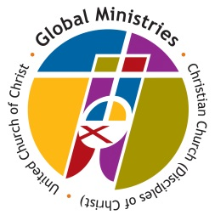 APPLICATION FOR PILGRIMAGE
People-to-People Pilgrimage Program

Please complete the following form. In completing the required information, you will enable us to share with our area executives and international ecumenical partners about your group and on the goals of your mission pilgrimage. Moreover, this information will provide us with historical facts of our Disciples and UCC group mission pilgrimages, enabling us to share with others your Global mission experience. We encourage you to thoroughly fill out this form and return it to this office at your earliest convenience.

What congregation / group do you represent?

Congregation address:

What Conference / Region are you a part of?

1. Which of the following best describes your People-to-People Mission Pilgrimage?

Work camp Medical mission
Cross-cultural experience/Educational trip Other:

2. Purpose(s) of Trip:

3. Specific type of activities in which you or your group will participate in as a part of the trip:

4. Number of persons traveling:

5. Name of group leader:

6. Group composition (i.e., youth, adults, women, pastors, etc.):

7. Country(ies): __________________________________________

8. Travel Dates: From ____________________ to ____________________
9. Type of lodging arrangements:
Tourist hotel
Guest house (if available)
Conference grounds (if available)
Other: _____________________

10. Any other information you think should be included at this time (please feel free to attach additional pages if necessary):

11. Please, provide us with the following contact (group leader) information, if available:
Mailing Address:
E-mail Address:
Telephone No.:
Fax No.:

Upon completion of this form, please keep a copy for your records. Please, do not hesitate to contact us if you need additional information. Thank you!

People-to-People Pilgrimage Program
Ph. (317) 713-2565, Fax (317) 635-4323
lhernandez@dom.disciples.org
Global Ministries
P.O. Box 1986, Indianapolis, IN 46206-1986
www.globalministries.org

