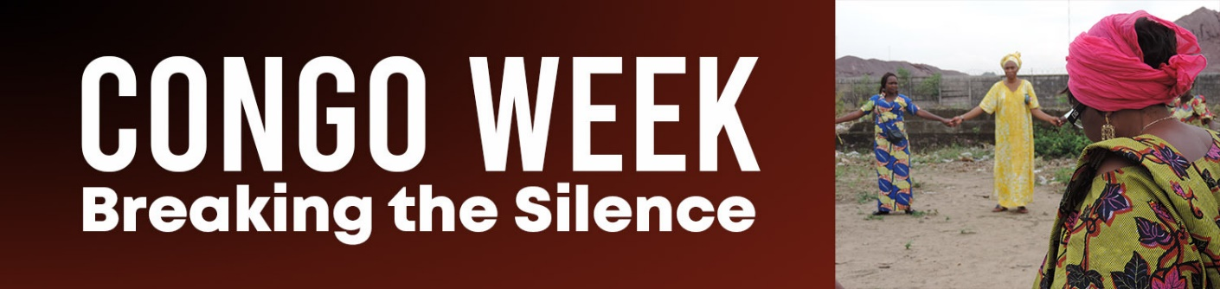

Worship Resources for Congo Week, October 18-24

Call to Worship

One: God of all creation, we come to worship You.

All: Creator of ever man, woman, youth, and child, we come to rejoice in you.

One: Maker of the heavens and the earth, please open us to your transforming grace.

All: God of liberation and life, may our acts of worship be a witness of your peace. As we lift our voices in praise, may our hearts and our hands be united in partnership with You and with our brothers and sisters in Congo.

Prayer of Confession

Merciful and Mighty God, we thank you for allowing us to come before with honesty and humility. Please forgive us when our actions lead to the oppression of others. Please forgive us when we ignore the pains and the joys of our neighbors near and far. When we feel like we can make no difference in the face of injustice and suffering, please redeem us and set us free with the good news that You are a God through whom all things are possible. When despair threatens to overwhelm, please fill us with your Spirit of hope and lead us forth with your saving love which knows no bounds. Amen.

Litany of Dedication

One: Giver of every breath, with gratitude that reaches beyond our words, we desire to offer you our best.

All: God of abundant blessings, we dedicate our lives to you. We seek to live out your purposes. We thank you for inviting us to be part of your mission in the world.

One: We thank you for designing each of your children with unique gifts, personalities, and experiences to be used for you glory.

All: We thank You for the generosity you shower upon us. We desire to offer back your blessings of time, talents, and treasures with cheerful hearts. Please make them one with the gifts of our partners that all may live together in your community of compassion, justice, peace, and love. Amen.

(By the Rev. Sarah Haas, Associate Pastor, Friedens United Church of Christ, Indianapolis, IN)

Litany

Nzambe (God), Transform our Compassion into Action

For the Congolese man caught up in war and mistrust and power of the elite, who feels trapped by circumstance and no easy solutions, who searches for a way to survive and find a livelihood,

Nzambe, transform our compassion into action.

For the Congolese widow whose husband died in a war over rocks in the ground, who sells fish or makes soap or sews in hopes to provide enough food or shelter from the night. Who are afraid to walk alone through the tropical fields. Who want their children to have a better life.

Nzambe, transform our compassion into action.

For the Congolese children who ache to learn to read or write but don’t have schools or teachers or books or money. For those without enough to eat, or wear, or safe water to drink, who gaze with frightened eyes because life is not safe or carefree or guaranteed.

Nzambe, transform our compassion into action.

For the Congolese doctors who agonize over the children they can’t reach or treat because the distance is too far, the medicines are not available, the needs are too great. Who watch little ones die of cholera for lack of access to what they need.

Nzambe, transform our compassion into action.

For the Congolese church that seeks to heal the wounds, whose spiritual wealth outweighs its material means, yet speaks hope to the suffering, provides opportunities and schools, builds wells and hospitals, that leads in ways of peace and praise, that gives heart and soul to serving the Lord.

Nzambe, transform our compassion into action.

(By Mrs. Cheryl Sybrant, First Christian Church, Fayetteville, AR, Traveler to Congo August 2012)

Song from the Congo Nzambe Osungaka Afrika. (God Help Africa)
One sings this song to the tune of Nkosi Sikelele Afrika (God Bless Africa), which is used in many African nations as a National Anthem.

- Nzambe osungaka Afrika, help Africa

pesa bato moindo moi na yo, Give your people your light

ete tolongwaka na mabe, So that our sins may be removed na lobiko be na yooo, Forever with you,
na lobiko be na yo. Forever with you

- Opambola mpe mikolo kwa, Bless our days (on earth) bango mpe batata na biso, Bless our fathers
Yebisa mikonzi mayele, Give our leaders wisdom Ete bamemisa yooo, That they may follow you
Ete bamemisa yo. That they follow you

- Kati na mosala tika ete, Within our work place, may tokokisa mpe kobanga te, We prove capable and fear not mpe toyekola mayele be, That we learn wisdom
mpe totosa solo yooo, And obey only you

mpe totosa solo yo. And obey only you

- Kati na ndako na biso, Within our homes ekokola bana na biso, Help our children to grow osunga bamama na biso, Help our mothers
pesa mpe bolingo beee, Give us love

pesa mpe bolingo be. Give us love

Réf.: Mobikisi, Klisto Yesu, Chorus: Healer, Christ Jesus awa na Congo Here in Congo
opambola, obongisa. Bless it and arrange it

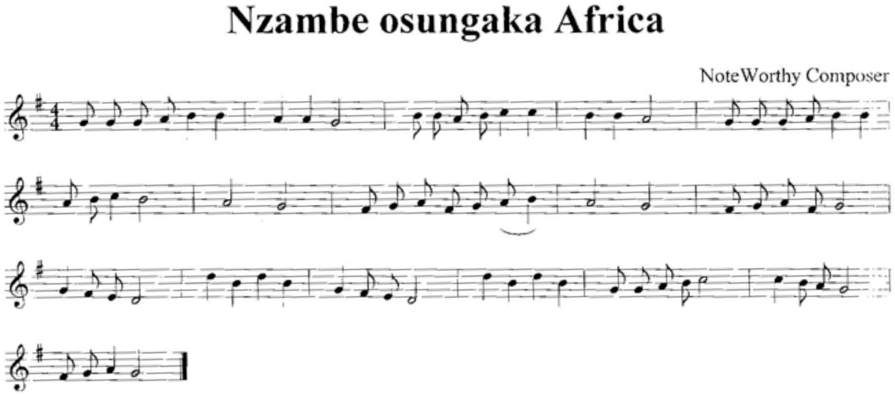

Prayers from the Congo

(By the Rev. Clement Mputu, Vice President of the 10th Community of Disciples of Christ au Congo)

There are many categories of prayers but we have chosen three categories of persons giving prayer.

Children
Children are first of all concerned with food, for the expression that always comes from the mouth of at least 99% of children in Congo is “I am hungry.” A child even said that one should not have to wait for the Sunday service to repeat the Lord’s Prayer, especially the part that says, “Give us today our daily bread” because one is hungry even before going to the service. One should say this prayer the first thing in the morning.

Children also need education to succeed. They also need good health because illness is the daily fate of children in the Congo.

Children’s Prayer:

Lord our God, we thank you for having protected us during the night. We ask that you give us enough good food to eat (sufficient in quality and quantity). Give us intelligence so that we may succeed at school. And we pray that you will heal those who are sick (grandmother, grandfather, sister, small brother, young sister, father, mother). We pray that you will protect us throughout the day. In the name of Jesus Christ, Amen.

Intellectuals
They are often concerned with work, decent salaries, the war, politics and justice.

The Intellectuals’ Prayer

Lord God, Great and Formidable, you whose love is immeasurable, in spite of all the difficulties that we face, from day to day, we realize that you come to our aid. Thank you for giving us intelligence and for giving us people who assist us with our studies. Yet, at the end of our studies we see that the doors of work opportunities are still closed. We pray that you will open them so that we can have work. We also pray for those who work because the salary that they receive has nothing to do with the work that they furnish. We pray Lord that you will help those in power to convert themselves and in cases to the contrary, that you will give us other leaders who allow themselves to be guided by you so that they lead the country with love and equity. From day to day we suffer from injustice at all levels. No authority can render true justice in the Congo. Even the war that reigns today in our country is the fruit of both internal and external justice. God of justice, what are you waiting for to bring justice? We only have You as a true Judge. Extend your hand so that one day we can smile and so that the world will realize that the God in whom we have confidence is the Only True God. In the name of Jesus Christ, Amen!

The Clergy
Also intellectuals, the clergy’s reflections are similar but they add particular instances such as peace, social situations with their harmful consequences (such as some traditional practices, delinquents, epidemics HIV/AIDS, etc.). This social situation compromises marital harmony in many homes. It is also necessary to highlight the heavy burden placed on the church because of this situation; what the state or government should do is being done by the church.

Clergy’s Prayer

Loving Father, God of Glory, you who never tire of listening to us, here we are again before you; accept our pleas. If the situation in the Congo is the result of our sins and those of our ancestors, we ask that you forgive us and that the Holy Spirit guide us.

We pray to you so that you grant peace to Congo, our nation, and also in the hearts of each Congolese. Your Son, before returning to You, left us with a peace different from that of the world. So, peace is precious and we want to keep it. We also pray for the social situation in the Congo. We live from day to day by miracle whereas in your plan humankind must not live by miracles but by the fruit of one’s labor. On a regular basis, your children are not able to obey the instructions of Christ prohibiting worrying about food and clothing in Matthew 6:28-30. This uncertainty is so huge

that one cannot help but to think about it. Some of your children have chosen the path of delinquency that leads to destruction to find justice. Some children are condemned to live in the street because they have been accused of being sorcerers, whereas, God, you know that they are not. AIDS continue its path in spite of human efforts; if you don’t intervene this will be a lost effort. Look at the epidemics that have become endemic and the couples and families that are regularly in danger.
Your servants that you have chosen feel incapable of giving solutions to problems presented by the mulitud of people who have their eyes fixed on them for your servants suffer in the same way that all the Congolese suffer. Grant us everything that is necessary so that we may continue to serve you in a normal way. In the name of Jesus Christ our Lord and our Role model. Amen.

LES PRIERES VENANT DU CONGO

Pour les prières, il y a beaucoup de catégories mais nous avons choisi trois catégories de personnes.

LES ENFANTS
Ils se préoccupent d’abord de la nourriture car la phrase qui revient toujours à plus de 99% dans la bouche des enfants au Congo est j’ai faim. Un enfant a même déclaré qu’on ne devait pas attendre le culte dominical pour dire l’oraison dominicale dans sa partie « donne nous aujourd’hui notre pain du jour » parce qu’il a faim avant même d’aller au culte. On devrait donc dire cette prière dès le matin.

Les enfants ont aussi besoin de l’intelligence pour réussir le jour de la proclamation. Ils ont besoin de la bonne santé car les maladies sont le lot quotidien des enfants au Congo.

Prière des enfants

Seigneur notre Dieu, nous te remercions pour nous avoir protégé durant toute la nuit. Nous te demandons de nous donner à manger beaucoup et bien (suffisant quantitativement et qualitativement). Donnes-nous l’intelligence pour réussir à l’école. Et nous te prions de guérir ceux qui sont malades (grand-mère, grand-père, sœur, frère, petit frère, petite sœur, papa, maman…). Nous te prions de nous protéger tout au long de la journée. Au Nom de Jésus-Christ. Amen !

LES INTELLECTUELS
Ils se préoccupent souvent de l’emploi, de salaire décent, de la guerre, de la politique et de la justice.

Prière des intellectuels

Seigneur Dieu grand et redoutable, toi dont l’amour est incommensurable, malgré toutes les difficultés que nous rencontrons, au jour le jour nous nous rendons compte que tu nous viens en aide. Merci pour nous avoir accordé l’intelligence et nous avoir donné des gens pour nous soutenir aux études. Mais à la fin de nos études nous voyons que les portes du travail nous sont encore fermées. Nous te prions de les ouvrir pour que nous puissions avoir du travail. Nous prions aussi pour ceux qui travaillent, parce que le salaire qu’ils reçoivent n’a aucun rapport avec le

travail qu’ils fournissent. Nous te prions Seigneur d’aider ceux qui sont au pouvoir de se convertir, dans le cas contraire, de nous donner d’autres responsables qui se laisseront diriger par toi pour diriger le pays avec amour et équité. Car au jour le jour nous souffrons de l’injustice à tous les niveaux. Aucune instance ne peut rendre la vraie justice au Congo. Même la guerre qui sévit aujourd’hui dans notre pays est le fruit de l’injustice interne et externe. Dieu Juste, qu’attends-tu pour faire la
justice ? Nous n’avons que Toi comme Vrai Juge ; étends ta main pour qu’un jour nous puissions sourire et que le monde réalise que le Dieu en qui nous faisons confiance est l’Unique Vrai Dieu. Au Nom de Jésus-Christ, Amen !

LES CLERGES
Etant des intellectuels, les clergés réfléchissent comme tel tout en ajoutant des particularités comme la paix, la situation sociale avec ses conséquences néfastes (les enfants dits sorciers, les kuluna (délinquants), les épidémies, la propagation du VIH/SIDA). Cette situation sociale complique l’harmonie conjugale dans plusieurs foyers. Il faut aussi épingler la lourde charge que porte l’Eglise à cause de cette situation ; ce que l’Etat devait faire, est réalisé par l’Eglise.

Prières des Clergés

Tendre Père, Dieu de gloire, Toi qui ne te fatigue pas de nous écouter, nous voici encore devant toi ; accepte nos supplications. Si la situation du Congo est la conséquence de nos péchés et ceux de nos ancêtres, veuilles nous les pardonner et que le Saint-Esprit nous conduise. Nous te prions pour accorder la paix au Congo notre nation et aussi dans le cœur de chaque Congolaise et Congolais. Ton Fils, avant de rentrer vers Toi, nous a laissé la paix différemment de celle du monde. La paix est donc chère et nous voulons la garder. Nous te prions aussi pour la situation sociale au Congo. Nous vivons au jour le jour par miracle. Alors que dans ton plan, l’homme ne doit pas vivre des miracles mais par les produits de ses mains.
Régulièrement tes enfants n’arrivent pas à obéir à l’instruction du Christ interdisant de s’inquiéter sur la nourriture et les vêtements dans Matt 6, 28-30. Car l’incertitude est tellement grande qu’on ne peut pas ne pas y réfléchir. Certains enfants ont choisi le chemin de Kuluna (les bado ou délinquants) pour se faire justice. Certains enfants sont condamnés à vivre dans la rue parce qu’accusés d’être sorciers, alors que Dieu, tu sais qu’ils ne le sont pas. Le Sida continue son chemin malgré les efforts humains ; si tu n’interviens pas ça sera une peine perdue. Regarde les épidémies qui deviennent endémiques et les couples et familles régulièrement en danger. Tes servantes et serviteurs que tu t’es choisi se sentent incapables de donner solution aux problèmes de toutes les multitudes qui ont les regards sur eux. Car tes serviteurs et servantes souffrent de la même manière que toutes les Congolaises et tous les Congolais. Accordes-nous tout ce qui est nécessaire pour que nous continuions à te servir normalement. Au Nom de Jésus-Christ notre Seigneur et notre Modèle. Amen !

Prayers for the Congo

Let us pray:

Nzámbe, Heavenly Father, Great Physician,

We praise you for the blessing of the Bolenge Hospital. We have seen your hand in its work since it was established so many years ago. You were present as community members saved patients from perishing in the fire. You continue to shower your blessings as funds have been made available to rebuild the hospital facilities. Thank you all mighty God for showing your love for the people of Congo by sending people and facilities that provide health care.

We ask you to continue to bless the Pediatric Wing as your children are cared for. Be with the staff and those they care for. You continued to bless your people by providing funds to build the Maternity Wing, a building dedicated to bringing new life into the world. Fill that structure with life and your light as it is equipped with beds and equipment. Watch over the dedicated craftsmen who are beginning the construction of the Surgery/General Medicine Wing. All praise to you great God for the talents and gifts that make such buildings possible.

This new construction brings a renewed hope as the partnership of your people here and abroad. This great work reinforces the presence of the Disciples of Christ in the Congo. Be with the people of the DRC and with us as we care for one another physically and spiritually.

Amen

(By Mrs. Stephanie Line, Galesburg Christian Church, Galesburg, IL, Traveler to the Congo August, 2012)

Reflection from the Congo SOCIAL SITUATION
Drinking Water

The majority of the Congolese population use water that is not fit for consumption, that is, it is a carrier of many diseases. As long as this situation continues, epidemics will not cease in the Congo.

Insignificant Salaries

Because of the meaningless salaries that the Congolese receive, the fight against corruption will not succeed. Children start taking care of themselves very early in life and are exposed to different scourges such as rape, early pregnancies, early parenthood. Some children choose the road to rebellion and are thought to be sorcerers and consequently living in the streets. Because of a need for money, many teachers no longer do their job as they should and Congo’s future is somber. There are many people who die because of the inadequate health care facilities in certain regions. There are places where people have to walk on foot more than 20

kilometers to reach a health center. Many people die on their way to the health center, which is often the case with women who die during childbirth.

Bad Governance

Bad governance is the basis of all the difficulties that the Congolese people confront internally or within the country. Curiously, some politicians defend themselves by saying that bad governance in the Congo is wanted and supported by the foreign powers. The Congolese people will never see a good manager healding the country because every plan that promotes good life in the congo is defeated. This argument is not very much supported, but certain realities makes one believe that there is some truth in the argument. For example, the international community speaks of and intervenes quickly to situations in other country, contrarily to its actions in the Congo. Kenya and the Ivory Coast were seen receiving support when there were problems after their elections. However, for the Congo, one limits its responses to weak declarations. The solution to the war in East today, will be in the interest of the international community but never for the people of Congo. The Ugandan President, an enemy of the Congo (for he also has been listed as an aggressor of Congo just as the Rwandan president has been), has been chosen to facilitate in the formation of a neutral force to be deployed to the East to combat the rebels. No Congolese can believe that such a person will play a role in favor of the Congo. Whereas Rwanda attacks the Congo in the knowledge and sight of the international community, all actions taken against Rwanda are proof of a certain sympathy and pity under the pretext that there is not enough space for the Rwandan population and that it is necessary to give them a part of the Congo. But we all know that China is one of the most dense countries in the world, but China has never attempted to attack its neighbors to find additional space. The genocide, which was supported by the world powers seemed to be against the Tutsi, whereas there was also attacks against the Hutus. Since that time until today, the number of Rwandese who are dead does not reach the number of Congolese who perished because of this invasion of Rwanda into the Congo. In spite of all that, there have not been strong measures taken to force Rwanda to leave East Congo. Had Congo been the attacker, there would have been very serious measures taken against Congo. For example, up until today, it has been 20 years since an arms embargo was placed on the Congo. Is that not a plan to make the Congo very fragile?

Taking the wealth of the country as an inherited right by the international community without considering those against this, only impoverish Congo even more. One takes good care of Congo and its wealth 9forest, minerals, water, chimpanzee, okapi..) without concerning oneself with the Congolese people. It is true that almost every year the number of Congolese who die is more elevated than the number of the entire population in certain countries,; and that is not known by the population of most people in the western world so that they can pressure their governments to bring a change in the situation.

We stop here as we think that we have given that which is essential. The Congo has many problems and we cannot say everything.

May God bless you!

Situation sociale Eau potable
La grande majorité de la population du Congo utilise une eau impropre à la consommation, c’est-à-dire porteuse de beaucoup de maladies. Tant que cette situation continuera, les épidémies ne cesseront pas au Congo.

Salaires insignifiants

A cause des salaires insignifiants que reçoivent les Congolaises et les Congolais, le combat contre la corruption ne réussis pas. Les enfants se prennent en charge très tôt et sont exposés aux différents fléaux comme les viols, les grosses précoces, les parents précoces. Certains enfants choisissent le chemin de la rébellion et sont taxés des sorciers vivant par conséquent dans la rue. Pour besoin d’argent, beaucoup d’enseignants ne font plus le travail comme il se doit et l’avenir du Congo reste sombre. Il y a beaucoup de gens qui meurent à cause de l’absence d’infrastructures hospitalières adéquates dans certains milieux. Il y a certains milieux où les gens doivent marcher à pied plus de 20 kilomètres pour atteindre un poste de santé. Beaucoup de gens meurent avant d’atteindre un poste de santé ; c’est souvent le cas des femmes qui meurent lors d’accouchement.

Mauvaise gouvernance

La mauvaise gouvernance est la base de toutes les difficultés que connaissent les Congolaises et les Congolais sur plan interne. Curieusement, certains politiciens se défendent en disant que la mauvaise gouvernance au Congo est voulue et soutenue par les grandes puissances. Les Congolaises et les Congolais ne verront jamais à la tête de leur pays un bon gestionnaire ; car tout plan qui vise le bonheur du Congo sera combattu. Cet argument n’est pas très soutenu, mais certaines réalités font croire à une partie de vérité de cet argument. Car la communauté internationale parle plus et intervient vite dans le cas des autres pays, contrairement au Congo. Le Kenya et la Côte d’Ivoire se sont vus soutenus lors qu’il y a eu des problèmes après les élections. Mais pour le Congo, on se limite à des déclarations assez faibles.
Aujourd’hui la guerre à l’Est, la solution que l’on en visage sera pour l’intérêt de la communauté internationale mais jamais pour le peuple congolais. Le président ougandais, ennemi du Congo (car lui aussi est cité comme agresseur du Congo comme le président rwandais), est choisi comme facilitateur dans la formation de la force neutre qui doit se déployer à l’Est du pays pour combattre les rebelles. Aucun Congolais ne peut croire qu’une telle personne pourra jouer un rôle en faveur du Congo.

Le Rwanda qui agresse le Congo au su et au vu de la communauté internationale, toutes les mesures prises contre le Rwanda font preuve d’une certaine sympathie et pitié sous prétexte qu’il manque de l’espace pour sa population et qu’il faut lui donner une partie du Congo. Mais nous savons tous que la Chine est l’un des pays le plus dense au monde, mais la Chine n’a jamais voulu agresser ses voisins pour se trouver un espace supplémentaire. Le génocide qui a été soutenu par les grandes puissances semblait être contre les Tutsi, alors qu’il y en avait aussi contre les Hutu. Depuis ce temps-là jusqu’aujourd’hui, le nombre des Rwandais qui sont morts n’atteigne pas le nombre des Congolais qui ont péri à cause de l’aventure du Rwanda au Congo. Malgré tout cela, il n’y a pas de mesures fortes obligeant le Rwanda à quitter l’Est du Congo. Mais si c’était le Congo qui aurait fait ça, il y aurait des mesures très très dures. Par exemple, jusqu’aujourd’hui, il y a plus de 20 ans

que le Congo a été frappé d’embargo sur les armes ; n’est-il pas là un plan pour fragiliser le Congo ?

La prise des richesses comme patrimoine internationale sans contre partie, ne fait qu’appauvrir le Congo. On s’occupe bien du Congo et de ses richesses (forêts, minerais, eau, bonobo, okapi…) sans s’occuper de la Congolaise et du Congolais. A vrai dire, presque chaque année le nombre des Congolaises et Congolais qui meurent est plus élevé que le nombre de tout un peuple dans certains pays ; et cela n’est pas connu par les populations des pays les plus puissants pour exiger des leurs autorités que cette situation change.

Nous nous arrêtons ici et pensons avoir donné ce qui est essentiel. Le Congo ayant beaucoup de problèmes, nous ne saurons tout dire.

Que Dieu vous bénisse !

Reflection from the US

(By Cheryl Sybrant, Fayetteville Christian Church, Fayetteville, AR)

It’s hard to answer the question people ask when you return. “How was the trip to Congo?” There are too many emotions and thoughts all tangled together. How do you boil an experience into the expected “sound bite” when so many words define it?

Amazing, exhausting, inspiring, faith-filled, saturated with joy and praise, powerful, culturally challenging, spiritual, uplifting, scary, beautiful, humid, heart breaking, and heart mending could each illustrate their own stories.

Mostly, this trip was a lesson in perspective, a study in contrast, between the material means we often place our trust in and the spiritual wealth I witnessed in Congo. We have so much to learn.

I wish more people could witness offering time in Congo! Rather than quietly waiting for the “tray to be hurriedly passed down the pew,” old and young sing and dance forward to the front of the church. They drop what money they have into baskets for various church ministries. The experience is a testament to what stewardship should represent—joy and thanksgiving and giving back what’s already Gods.

And God knows there is need. There is a constant struggle: to stay alive, to have enough food, to have safe water, to have medical care or a school for your child. The list is overwhelming. But the more I listened and observed, the more I learned that the people we met put their trust and faith in God, and empowered by the Holy Spirit, the church provides, somehow, against all odds.

It builds schools, hospitals, medical clinics, digs wells for entire villages; provides doctors, and economic opportunity for survival. The church is not contained in a building, it embraces the entire community. And by the grace of God its servants “lift up those who are bowed down, uphold the widow and the fatherless, keep the faith, execute justice for the oppressed, give food to the hungry.” I saw the God of Psalm
146 working in the flesh through the 10th Community of Disciples of Christ in Congo (CDCC) and efforts of Global Ministries. Their faith and dedication provide the means to accomplish great things in the midst of suffering and struggle.

At the CDCC Headquarters in Mbandaka, we met the Christian Women’s Fellowship group from 23 different districts throughout Congo. They are another testament to spiritual wealth. They came for a two-week training session to learn more about the mission and vision of the church so they could apply it back home in their districts.
They used their own money and some traveled weeks by foot and canoe just to get there. One woman walked 186 miles to attend! In a country with a reputation for being “the most dangerous place to be a woman,” what faith.

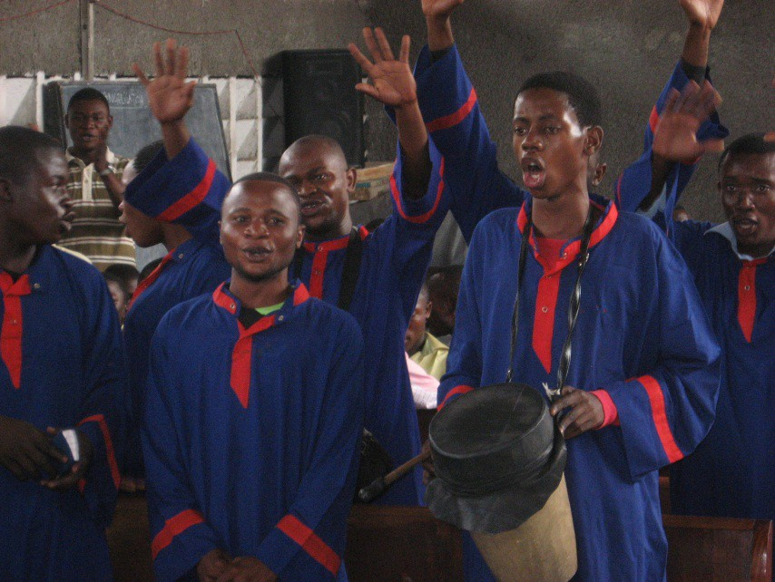
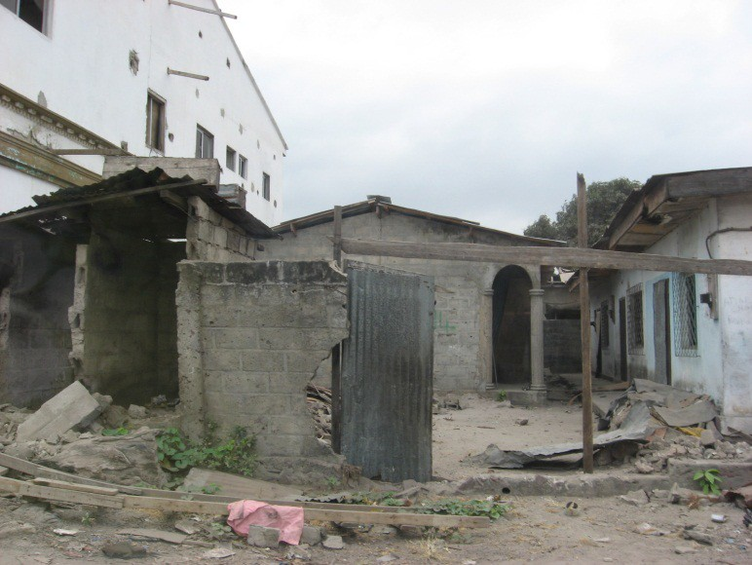
In Brazzaville, where we visited the Church of the Disciples of Christ in Congo (EDCC), we got another reminder of what it means to truly praise the Lord despite surrounding circumstances. The congregation we visited lost four members during an ammunitions depot explosion in March which took 3,200 lives, destroyed schools and the hospital and damaged buildings miles across the river into Kinshasa.

Signs are posted not to step on live hand grenades or ammunition. Tents are set up, and people live in what’s left of homes. But on a Thursday, the congregation waited hours for our arrival and a chance to worship and show hospitality.
One choir traveled over 600 miles to sing. With heart and soul, they lifted up praise. A young man on guitar played “How Great Thou Art” while the minister prayed. I felt so unworthy because all I could think was, “God, things don’t
look so great.” But despite the destruction around them, they spoke with incredible perspective and compassion. The minister gave each of us a small purse with a map of Africa and a selfless directive: “When you go back home don’t only be ambassadors for Brazzavile; be ambassadors for Africa, because there are places worse off than we are.”

I pray God empowers us and guides us to fulfill that request.

Reflection from the US

(By the Rev. Eugene James, Regional Minister of the Christian Church (Disciples of Christ), Michigan Region)

A Reflection from Time with the Saints in Congo

There is a saying with which most of us are familiar: “You don’t miss your water until the well runs dry.” How about first having to find water to miss? Coming home to running water I could actually drink made vivid the point of just how blessed I am to live in a community where it is taken for granted. During our time in Mbandaka, we visited two clean water sources developed by the church and witnessed first hand just how critical to the community they are. There was a steady stream of persons, mostly women and children, coming down the path to the water source with buckets and containers of various sizes to obtain water to carry back to there homes. They filled the containers, balanced them on their heads and made their way back up the hill and onto the road to their distant homes. I particularly remember one young mother with her three children, probably ranging in age from six to twelve years old, standing tall in her determined dignity, telling us that life for her family was hard and having the clean water source was very important to them. The image of her youngest child who turned to watch me walk up the path with a bucket of water almost as tall as she was balanced on her head is burned into my memory forever. None of the children whined or complained about it being difficult to walk up the path or the containers of water being too heavy. They simply did what had to be done.
What a profound example of shared responsibility for children in our privileged society.

